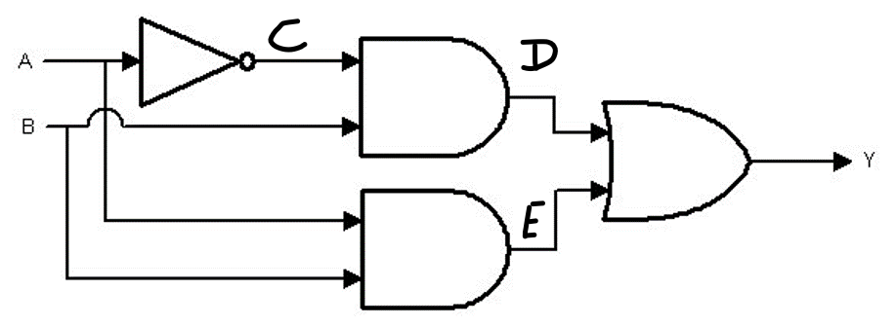

|  |  |  |  |  |  |
| --- | --- | --- | --- | --- | --- |
| A | B | C | D | E | Y |
| 0 | 0 | 1 | 0 | 0 | 1 |
| 0 | 1 | 1 | 1 | 0 | 1 |
| 1 | 0 | 0 | 0 | 0 | 0 |
| 1 | 1 | 0 | 0 | 1 | 1 |

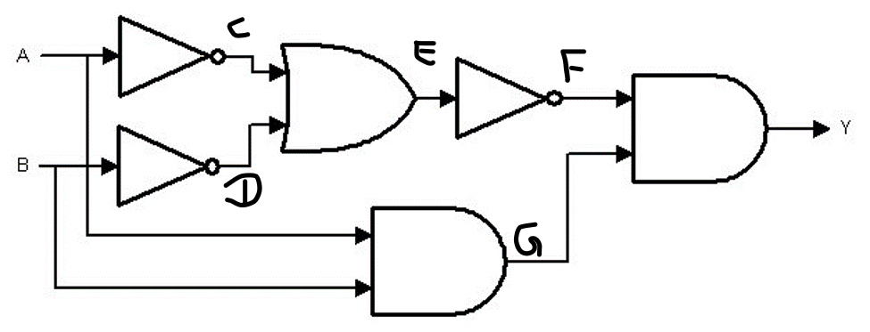

|  |  |  |  |  |  |  |  |
| --- | --- | --- | --- | --- | --- | --- | --- |
| A | B | C | D | E | F | G | Y |
| 0 | 0 | 1 | 1 | 1 | 0 | 0 | 0 |
| 0 | 1 | 1 | 0 | 1 | 0 | 0 | 0 |
| 1 | 0 | 0 | 1 | 1 | 0 | 0 | 0 |
| 1 | 1 | 0 | 0 | 1 | 0 | 1 | 0 |

Convert 110101 from Binary to Decimal

Convert 98 from Decimal to Binary

Convert 534 from Decimal to Hexa

Convert 1FA from Hexa to Decimal Conversion